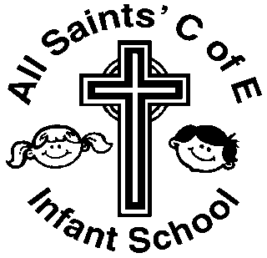

The information below compares the attainment in 2024 of our pupils against the national average.

**Early Years Foundation Stage**

**58%** of pupils in Reception attained a Good Level of Development against the Early Years Framework. The 2023 national percentage was 67.2%.

A Good Level of Development is defined as children working at the expected standard or exceeding the expected standard in the key areas of literacy, maths, physical development, communication and language and personal, social and emotional development.

**Year One Phonic Screening**

**71.4%** of pupils in Year One attained the expected standard in the Phonic Screening test. The 2023 national percentage was 79%.

**Key Stage One Phonic Screening**

**80%** of pupils in Key Stage 1 passed the Phonic Screening test by July 2024.

**Key Stage One**

At the end of KS1, teachers are required to assess each child in the areas of reading, writing, maths and science. National Curriculum assessment tests are used to support teachers’ judgements. For more information please see the leaflet [Information for parents KS1](https://www.gov.uk/government/publications/2017-national-curriculum-assessment-results-at-the-end-of-key-stage-1-information-for-parents) from the Standards and Testing Agency.

Judgements are made as follows:

**Expected Standard** – Working at the expected standard for a child at the end of Year 2

**Greater Depth** – Working at greater depth within the expected standard, with a strong understanding of the curriculum.

|  |  |  |
| --- | --- | --- |
| **END OF KS1 SATs RESULTS** | **All Saints Infants**  **2024** | **National Average**  **2023** |
| **Reading – Expected Standard** | **60%** | 67% |
| **Reading – Greater Depth** | **20%** | 18% |
| **Writing – Expected Standard** | **55%** | 58% |
| **Writing – Greater Depth** | **10%** | 8% |
| **Maths – Expected Standard** | **60%** | 68% |
| **Maths – Greater Depth** | **10%** | 16% |