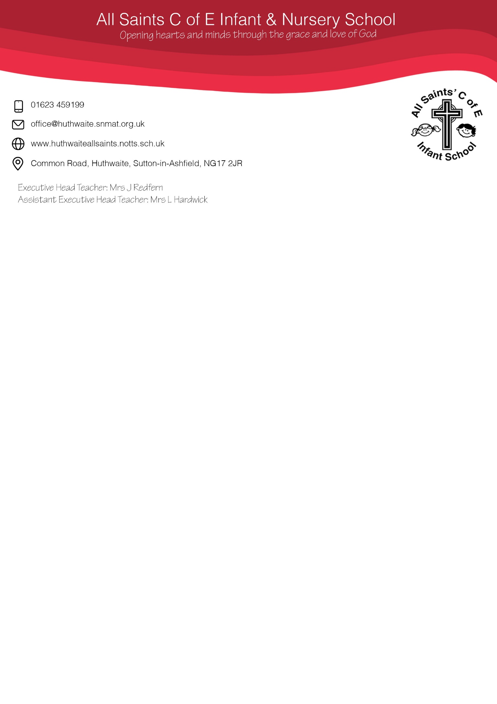

01623 459199

office@huthwaite.snmat.org.uk

www.huthwaite.snmat.org.uk

Common Road, Huthwaite, Sutton-in-Ashfield, NG17 2JR

Executive Head Teacher: Mrs J Redfern

Acting Head Teacher: Ms L Hardwick

Dept Head Teacher: Miss K Woods

**Admission Form**

Please complete this form as fully and accurately as possible. It is really important that we have the most up to date information on your child whilst they are in our school.

Once complete, please return to the school office as soon as possible, or on your child’s first day in school along with a copy of their birth certificate for verification.

All information will be kept strictly private and confidential under the GDPR guidelines.

**Please complete in BLOCK CAPITALS.**

Child’s Legal Forename: ___________________________________________

Middle Name(s): ___________________________________________

Child’s Legal Surname: ___________________________________________

# *As it appears on birth certificate.*

# *Office Use: Birth Certificate seen on: _____________________*

Chosen Name: ____________________________________________

Date of Birth *dd/mm/yyyy*: _______ / _______/ _________ Gender: M F

Home Address _____________________________________

____________________________________________

Postal Code ___________________________________________

If any of the following apply to your child, please tick the relevant box:

Parent in the Armed Services

Traveller

In Care or ever been in Care If so, which Local Authority: ___________________

Special Educational Needs (SEN)

Social Worker allocated Child in Need / Child Protection Plan in place

Child entitled to Free School Meals (*FSM)* (NB: Not Universal Infant FSM)

Please check <https://www.gov.uk/apply-free-school-meals> for further information and to check eligibility.

Any Siblings in the family home: (*Please list full names and age*) ___________________________________________________________________________

___________________________________________________________________________

Previous School or Nursery Attended (inc. Address & Tel No): ______________________

___________________________________________________________________________

___________________________________________________________________________

Password to be used when a person is to collect your child who is NOT on our emergency contact list:

___________________________________

**Medical Information**

Current Doctors Surgery: _________________________________________

Address/Tel No. of Surgery: _________________________________________

_________________________________________

Does your child have any known allergies: Yes No

If yes, please state and provide us with a copy of any doctor/hospital letters for their file:

___________________________________________________________________________

Does your child suffer with Asthma: Yes No

If yes, do they require an inhaler in school: Yes No

*If yes, please ensure an Asthma Registration Form is completed and an inhaler/spacer is provided into school at your earliest convenience. This should be new, in date and have your child’s name on it.*

Does your child have any other medical conditions or disabilities we need to be aware of:

Yes No If Yes, please give further details below:

____________________________________________________________________________

____________________________________________________________________________

Does your child have any dietary requirements that we need to be aware of:

Yes No If Yes, please give further details below:

____________________________________________________________________________

____________________________________________________________________________

*If yes, then please ensure a E46 dietary form is completed and provided to the school at your earliest convenience. Until a form has been handed in and a meeting has been conducted with the School Chef, we are unable to make any changes to their file.*

**Parent / Carer Details**

**Parent/Carer 1 Contact Details** *This will be the first person we will contact in an emergency.*

Full Name inc. Title: _______________________________________

Relationship to child: _______________________________________

Home Address: Same as child

If different, ________________________________________

please specify where: ________________________________________

Daytime /Work Phone: ________________________________________

Mobile Number: ________________________________________

Home Phone: ________________________________________

Email: ________________________________________

Does this person have Parental Responsibility: Yes No

Are you a single parent family: Yes No

**Parent/Carer 2 Contact Details**

Full Name inc. Title: _______________________________________

Relationship to child: _______________________________________

Home Address: Same as child

If different, ________________________________________

please specify where: ________________________________________

Daytime /Work Phone: ________________________________________

Mobile Number: ________________________________________

Home Phone: ________________________________________

Email: ________________________________________

Does this person have Parental Responsibility: Yes No

Are you happy for this person to collect: Yes No

Are you happy for this person to be contacted in an emergency after Contact 1: Yes No

Is there any court order in place for this child relating to the above parents/carers?

Yes No *If yes, please ensure the original court order is shown to the school office as soon as possible so we can update the child’s details accordingly.*

**Other Emergency Contacts**

*In case of an emergency and when we cannot get in contact with the main parents/carers of the child, we need an additional contact(s) for us to use. Please provide details of any other person you are happy for us to contact in this instance.*

**Emergency 1 Contact Details**

Full Name inc. Title: _______________________________________

Relationship to child: _______________________________________

Home Address: ________________________________________

________________________________________

Daytime /Work Phone: ________________________________________

Mobile Number: ________________________________________

Home Phone: ________________________________________

Are you happy for this person to collect: Yes No

**Emergency 2 Contact Details**

Full Name inc. Title: _______________________________________

Relationship to child: _______________________________________

Home Address: ________________________________________

________________________________________

Daytime /Work Phone: ________________________________________

Mobile Number: ________________________________________

Home Phone: ________________________________________

Are you happy for this person to collect: Yes No

**Emergency 3 Contact Details**

Full Name inc. Title: _______________________________________

Relationship to child: _______________________________________

Home Address: ________________________________________

________________________________________

Daytime /Work Phone: ________________________________________

Mobile Number: ________________________________________

Home Phone: ________________________________________

Are you happy for this person to collect: Yes No

**Ethnicity Information**

*As a school, we require additional information on your child to provide them with the best support possible whilst they are with us at our school. It would be very beneficial for us if you could complete the below information as accurately and up to date as possible.*

*Please put a tick next to the relevant section that best describes your child:*

**Ethnic Origin**

Any other Asian background Gypsy/Roma

Any other Black background Indian

Any other Ethnic group Pakistani

Any other Mixed Background Traveller of Irish heritage

Any other White background White & Asian

Bangladeshi White British

Black African White Irish

Black/Caribbean White/Black African

Chinese White/Black Caribbean

Wish to not disclose

**Religion**

Buddhist Muslim

Christian No Religion

Hindu Other Religion

Jewish Sikh

Wish to not disclose

**Home Language**

Albanian/Shqip Hebrew Spanish

Arabic Hindi Swedish

British Sign Language Italian Turkish

Chinese Japanese Urdu

Danish Korean Welsh/Cymraeg

Dutch/Flemish Kurdish

English Luganda Other- Please specify:

French Norwegian ______________________________

Gaelic/Irish Panjabi ______________________________

German Polish

Greek Portuguese Wish not to disclose

Gujarati Russian

Romany/English Romanes Serbian/Croatian/Bosnian

First Language: ____________________________

Country of Birth: ____________________________

Nationality (as stated on passport): ____________________________