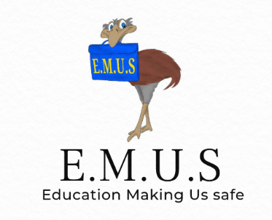

Parents information sheet
Week 1
This week in our E.M.U.S lesson, we have been learning about:
Rules and why we have them.
Rules and why we have them
The children have been learning about how rules can help to keep the world fair and can help to keep us safe.
We looked at some of the rules in school and at some traffic rules (we shall be looking in more detail at safety on the road later in the programme)
Ena the emu
Finally I introduced the children to Ena the emu who will be helping them as they learn how to keep safe over the course of the next 10 weeks.

Please help at home:
- Ask your child to tell you about what they have learned today using the information above to prompt them if necessary.
- Talk about some of the rules you have at home (bedtimes, mealtimes, chores…). Talk about why these are important even though we don’t always like them.
- Look at the enclosed rule-breaker worksheet and complete it together
- Please send the completed worksheet back in to school in time for next week’s session. Please feel free to add any comments on the back of the worksheet. I am always looking to improve the service I offer and very much welcome the input of parents.

Stay Safe
Mrs Butkevicius

