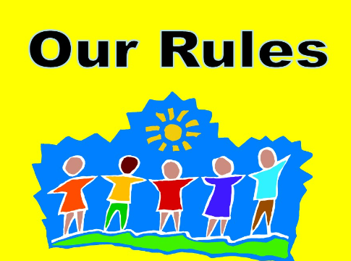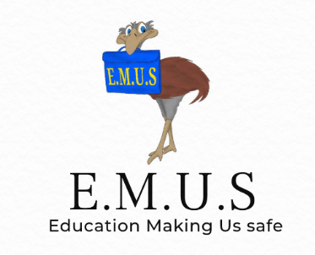
Rules
We have been learning about rules, why we have them and what happens if rules are broken.
We agreed that rules keep our world safe and fair.
We learned that there are consequences if we break the rules.
Have a look at the examples of rule breaking below. With your helper, can you think what the consequences would be. The first two have been done for you.
Broken rule | Consequences
A child in your class doesn’t listen during the maths lesson. They mess about instead. | They won’t be able to complete their work. They won’t get better at maths. Other people will be distracted and won’t be able to listen.
Someone rides their bike down a road that has a sign saying ‘No bikes’. | They might be in danger from fast vehicles.  They might put other people in danger.
Someone crosses the road without waiting for the green man to show its safe.

A child hits another child at playtime.

A driver is talking on the their mobile phone whilst they are driving along.

Someone drops rubbish on the floor all the time instead of putting it in the bin.

